SIMATS ENGINEERING
Department of Artificial Intelligence and Data Science
Annexure A
Scenario-Based Requirement Analysis
Software Requirement Specification (SRS) for an Online E-Commerce Retail System

Submitted By | Y. Rishitha Reddy
Register No. | 192424233
Department | Artificial Intelligence and Data Science
Subject | Software Engineering
Faculty | Dr. Latha R
College | SIMATS Engineering
Academic Year | 2024 – 2028

Table of Contents
1. Introduction 3
1.1 Purpose 3
1.2 Scope 3
1.3 Intended Audience 3
1.4 Definitions, Acronyms and Abbreviations 3
2. Problem Description / Scenario 4
2.1 Business Domain 4
2.2 Stakeholders 4
2.3 Existing Challenges 4
2.4 System Objectives 4
3. Functional Requirements 5
3.1 User Management 5
3.2 Product Catalogue & Search 5
3.3 Shopping Cart & Checkout 5
3.4 Payment & Order Management 5
3.5 Administration & Reporting 6
3.6 Reviews & Delivery 6
4. Non-Functional Requirements 6
5. Actors and Use Cases 7
5.1 Primary and Secondary Actors 7
5.2 Major Use Cases per Actor 7
5.3 Use Case Descriptions 7
5.4 Use Case Diagram 9
6. Data Requirements 9
7. External Interface Requirements 9
7.1 User Interfaces 9
7.2 Hardware Interfaces 10
7.3 Software Interfaces 10
7.4 Communication Interfaces 10
8. System Features 10
8.1 Key System Features Summary 10
9. Assumptions and Constraints 11
9.1 Assumptions 11
9.2 Constraints 11
10. Requirement Validation — Completeness and Consistency 11
10.1 Stakeholder Requirement Coverage Check 11
10.2 Checks for Ambiguity, Redundancy, and Inconsistency 11
10.3 Suggested Improvements 12
11. Conclusion 12

1. Introduction

1.1 Purpose
The purpose of this Software Requirement Specification (SRS) document is to provide a complete and detailed description of the functional and non-functional requirements for the proposed Online E-Commerce Retail System. This document is intended to serve as a communication bridge between stakeholders — including the business owner, development team, quality assurance team, and end users — ensuring that all parties share a common understanding of what the system will deliver.
The document is prepared as part of the Scenario-Based Requirement Analysis exercise for the Software Engineering course, following the requirement elicitation, analysis, and specification process taught in the coursework.

1.2 Scope
The proposed system, referred to as the Online E-Commerce Retail System, is a web and mobile-based platform that enables customers to browse, search, and purchase products online. The system will support product cataloguing, shopping cart management, secure checkout, multiple payment options, order tracking, and customer reviews. On the administrative side, the system will allow sellers/administrators to manage the product catalogue, inventory, orders, promotions, and generate sales reports. The system will also integrate with third-party payment gateways and logistics/courier services for order fulfilment and delivery.
The system is intended to reduce manual effort in order processing, minimise inventory mismatches, improve customer experience through personalised recommendations, and provide the business with real-time visibility into sales and operations.

1.3 Intended Audience
- Project stakeholders and business owners evaluating the proposed solution
- Software developers and architects responsible for system design and implementation
- Quality assurance engineers responsible for test case design and validation
- Project supervisors/faculty evaluating the requirement analysis

1.4 Definitions, Acronyms and Abbreviations
Term | Description
SRS | Software Requirement Specification
UML | Unified Modeling Language
FR | Functional Requirement
NFR | Non-Functional Requirement
UI/UX | User Interface / User Experience
API | Application Programming Interface
SKU | Stock Keeping Unit — unique identifier for each distinct product
Admin | Administrator/Seller managing the platform back-end
Payment Gateway | Third-party service that authorises and processes online payments

2. Problem Description / Scenario
Small and medium-scale retail businesses currently rely largely on physical storefronts or informal channels such as social media and messaging apps to sell products. This approach limits their reach to a local customer base, makes inventory tracking error-prone, and offers no structured way to manage orders, payments, or delivery logistics. Customers, in turn, face inconvenience in comparing products, tracking orders, and making secure payments outside a dedicated platform.
The business requires a centralised, scalable Online E-Commerce Retail System that allows customers to discover and purchase products conveniently from any device, while giving the business owner a structured back-end to manage products, orders, inventory, and promotions. The system must handle a growing product catalogue and increasing order volumes, particularly during peak sale periods, without compromising performance or reliability.

2.1 Business Domain
The business domain is Retail / E-Commerce, specifically business-to-consumer (B2C) online retail covering categories such as electronics, apparel, groceries, and general merchandise.

2.2 Stakeholders
Stakeholder | Interest / Role
Customers | Browse, purchase, and track products; expect a fast, secure, and easy-to-use platform
Business Owner / Admin | Manage catalogue, inventory, orders, and view sales performance
Sellers / Vendors | List products and fulfil orders on the platform (in a marketplace model)
Delivery Partners | Receive and update the status of order deliveries
Payment Service Providers | Process and authorise online payment transactions securely
Development & QA Team | Design, build, test, and maintain the system

2.3 Existing Challenges
- No centralised platform to manage products, orders, and customers together
- Manual order tracking leads to delays and errors in delivery updates
- Limited payment options and lack of secure, integrated payment processing
- No structured reporting to analyse sales trends and inventory needs
- Poor customer experience due to lack of search, filtering, and recommendation features

2.4 System Objectives
- Provide a seamless online shopping experience across web and mobile platforms
- Enable secure, reliable, and diverse payment processing
- Provide administrators with tools to manage catalogue, inventory, and orders efficiently
- Support real-time order tracking for customers and delivery partners
- Generate actionable sales and inventory reports for business decision-making
- Ensure the system is scalable to accommodate business growth and seasonal demand spikes

3. Functional Requirements
Functional requirements define the specific behaviours and functions the Online E-Commerce Retail System must support. They are grouped by module below.

3.1 User Management
ID | Requirement Description
FR-01 | The system shall allow customers to register using email, phone number, or social login.
FR-02 | The system shall allow registered users to log in and log out securely.
FR-03 | The system shall allow users to reset a forgotten password via OTP or email link.
FR-04 | The system shall allow users to view and edit their profile, addresses, and preferences.
FR-05 | The system shall allow guest users to browse products without registration.

3.2 Product Catalogue & Search
ID | Requirement Description
FR-06 | The system shall display products with images, descriptions, price, and availability.
FR-07 | The system shall allow users to search products by keyword, category, brand, and price range.
FR-08 | The system shall allow users to filter and sort search results (price, rating, newest).
FR-09 | The system shall recommend related or similar products to the user.
FR-10 | The system shall allow administrators to add, update, and remove products from the catalogue.

3.3 Shopping Cart & Checkout
ID | Requirement Description
FR-11 | The system shall allow users to add, update quantity, and remove items from the cart.
FR-12 | The system shall persist cart contents across sessions for logged-in users.
FR-13 | The system shall calculate order totals including taxes, discounts, and shipping charges.
FR-14 | The system shall allow users to apply valid coupon or promo codes at checkout.
FR-15 | The system shall allow users to select or add a shipping address during checkout.

3.4 Payment & Order Management
ID | Requirement Description
FR-16 | The system shall support multiple payment modes: credit/debit card, UPI, net banking, and cash on delivery.
FR-17 | The system shall integrate with a third-party payment gateway for transaction processing.
FR-18 | The system shall generate an order confirmation and invoice upon successful payment.
FR-19 | The system shall allow users to view current and past order history with status.
FR-20 | The system shall allow users to cancel an order within an allowed time window.
FR-21 | The system shall notify users of order status changes via email/SMS/push notification.

3.5 Administration & Reporting
ID | Requirement Description
FR-22 | The system shall allow administrators to view, update, and process incoming orders.
FR-23 | The system shall allow administrators to manage inventory levels and low-stock alerts.
FR-24 | The system shall allow administrators to create and manage discounts/promotional campaigns.
FR-25 | The system shall generate sales, revenue, and inventory reports over selectable date ranges.
FR-26 | The system shall allow administrators to manage customer accounts (view, suspend, or reactivate).

3.6 Reviews & Delivery
ID | Requirement Description
FR-27 | The system shall allow customers to rate and review purchased products.
FR-28 | The system shall allow delivery partners to update the shipment/delivery status of an order.
FR-29 | The system shall allow customers to track the real-time status of their order/delivery.

4. Non-Functional Requirements
Non-functional requirements define the quality attributes and constraints under which the system must operate.
Category | Requirement Description
Performance | The system shall load product listing pages within 2 seconds under normal load (up to 5,000 concurrent users) and process checkout transactions within 3 seconds.
Security | The system shall encrypt sensitive data (passwords, payment details) using industry-standard encryption (e.g. AES-256, TLS 1.2+) and comply with PCI-DSS for payment handling.
Reliability | The system shall maintain data consistency for orders and payments even in case of network failure, using transaction rollback mechanisms.
Usability | The system shall provide an intuitive, responsive UI accessible on desktop, tablet, and mobile screen sizes, requiring no more than 3 clicks to reach checkout from any product page.
Scalability | The system shall be designed using a modular/microservice-based architecture to scale horizontally during high-traffic events such as festive sales.
Maintainability | The system shall follow modular coding standards and maintain version-controlled documentation to allow easy updates and bug fixes.
Availability | The system shall maintain 99.5% uptime, with scheduled maintenance windows communicated to users in advance.
Interoperability | The system shall expose well-documented REST APIs to integrate with external payment gateways and logistics providers.
Portability | The system's front-end shall be accessible across major browsers (Chrome, Firefox, Safari, Edge) without loss of functionality.

5. Actors and Use Cases

5.1 Primary and Secondary Actors
Actor | Type | Description
Customer | Primary | A registered user who browses, purchases, and tracks products/orders
Guest User | Primary | An unregistered visitor who can browse products and must register to purchase
Admin | Primary | Manages the product catalogue, inventory, orders, promotions, and reports
Delivery Partner | Secondary | Updates the delivery/shipment status of orders
Payment Gateway | Secondary (external system) | Authorises and processes payment transactions initiated by customers

5.2 Major Use Cases per Actor
Actor | Associated Use Cases
Customer | Register/Login, Browse & Search Products, Manage Shopping Cart, Checkout & Place Order, Make Payment, Track Order Status, Write Product Review, Manage Wishlist
Guest User | Browse & Search Products, Register/Login (to proceed to purchase)
Admin | Manage Product Catalogue, Manage & Process Orders, Manage User Accounts, Generate Sales Reports, Manage Inventory, Manage Discounts & Promotions
Delivery Partner | Update Delivery Status, View Assigned Orders
Payment Gateway | Process Payment, Send Payment Confirmation

5.3 Use Case Descriptions
A representative sample of detailed use case descriptions is provided below for the most critical interactions.
Field | Details
Use Case ID / Name | UC-01 — Checkout and Place Order
Actor(s) | Customer
Description | Allows a logged-in customer to review cart items, select a shipping address, apply a coupon, and place an order.
Preconditions | Customer is logged in and has at least one item in the shopping cart.
Main Flow | 1. Customer opens cart 2. Reviews items and applies coupon (optional) 3. Selects/adds shipping address 4. Confirms order summary 5. Proceeds to payment (includes UC-02)
Postconditions | An order record is created with status 'Pending Payment'.
Exceptions | If an item becomes out of stock during checkout, the system notifies the customer and removes the item from the order.

Field | Details
Use Case ID / Name | UC-02 — Make Payment
Actor(s) | Customer, Payment Gateway
Description | Processes the customer's chosen payment method through the integrated payment gateway.
Preconditions | An order has been created with status 'Pending Payment'.
Main Flow | 1. Customer selects a payment mode 2. System redirects/connects to payment gateway 3. Gateway authorises transaction 4. System updates order status to 'Confirmed' 5. Confirmation is sent to the customer
Postconditions | Order status updated to 'Confirmed' and invoice generated.
Exceptions | If payment fails, the order remains 'Pending Payment' and the customer is prompted to retry.

Field | Details
Use Case ID / Name | UC-03 — Manage Product Catalogue
Actor(s) | Admin
Description | Allows the administrator to add, edit, or remove products and update stock levels.
Preconditions | Admin is logged in with catalogue-management privileges.
Main Flow | 1. Admin opens catalogue management 2. Adds/edits product details (name, price, images, stock) 3. Saves changes 4. System updates the live catalogue
Postconditions | Product catalogue reflects the updated information immediately.
Exceptions | If mandatory fields are missing, the system rejects the save and highlights errors.

5.4 Use Case Diagram
The diagram below illustrates the interactions between the identified actors and the major use cases of the Online E-Commerce Retail System.
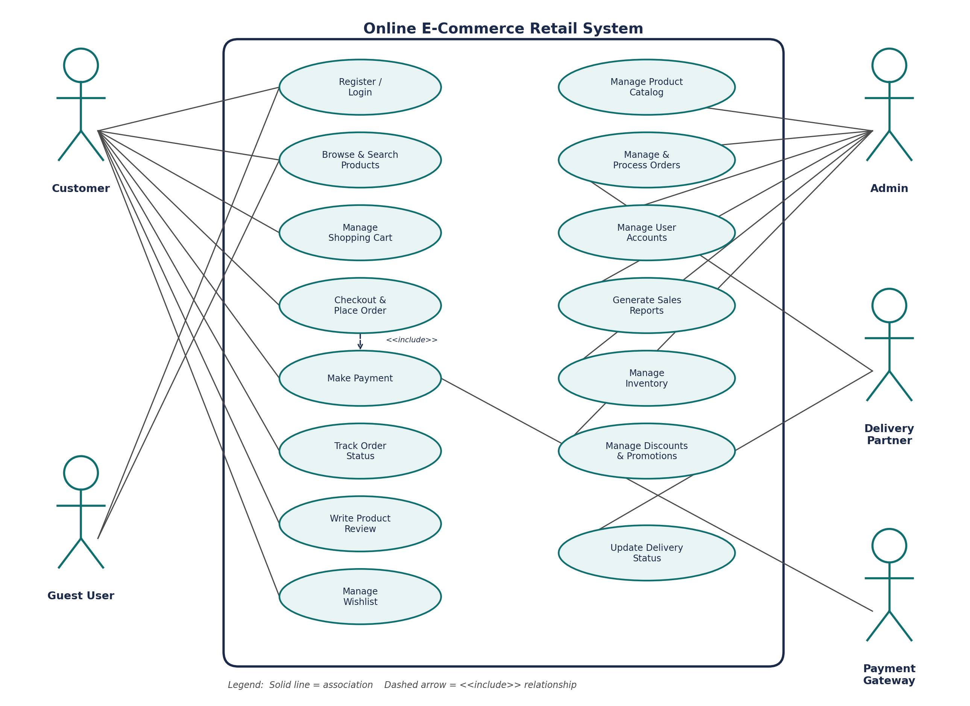
Figure 1: Use Case Diagram — Online E-Commerce Retail System

6. Data Requirements
The system requires structured storage of the following key data entities, each with essential attributes:
Entity | Key Attributes
User | UserID, Name, Email, Phone, PasswordHash, Address(es), Role (Customer/Admin)
Product | ProductID (SKU), Name, Description, Category, Price, StockQty, Images, Rating
Cart | CartID, UserID, ProductID(s), Quantity, AddedDate
Order | OrderID, UserID, OrderDate, Items, TotalAmount, Status, ShippingAddress
Payment | PaymentID, OrderID, Amount, Mode, TransactionID, Status, Timestamp
Review | ReviewID, UserID, ProductID, Rating, Comment, Date
Promotion | PromoID, Code, DiscountType, Value, ValidFrom, ValidTo
Delivery | DeliveryID, OrderID, PartnerID, Status, ExpectedDate, UpdatedDate
Data shall be retained in a relational database with referential integrity between Users, Orders, Payments, and Products. Personally identifiable information and payment data shall be encrypted at rest and in transit, and access shall be restricted using role-based access control.

7. External Interface Requirements

7.1 User Interfaces
- A responsive web application accessible via desktop and mobile browsers.
- A native/hybrid mobile application for customers (Android and iOS).
- A dedicated administrative web dashboard for catalogue, order, and report management.

7.2 Hardware Interfaces
- Standard client devices: desktops, laptops, tablets, and smartphones with internet connectivity.
- Server-side hardware/cloud infrastructure capable of hosting the application, database, and load balancers.

7.3 Software Interfaces
- Integration with third-party Payment Gateway APIs (e.g. Razorpay, PayU, Stripe) for transaction processing.
- Integration with Courier/Logistics APIs for shipment booking and delivery status updates.
- Email/SMS/Push Notification service integration for order and account alerts.

7.4 Communication Interfaces
- HTTPS-based RESTful API communication between client applications and the application server.
- Secure webhook callbacks from the payment gateway to confirm transaction status.

8. System Features
The following system architecture supports the features described above, structured as a layered application separating client interfaces, core business services, and data/external system integrations.
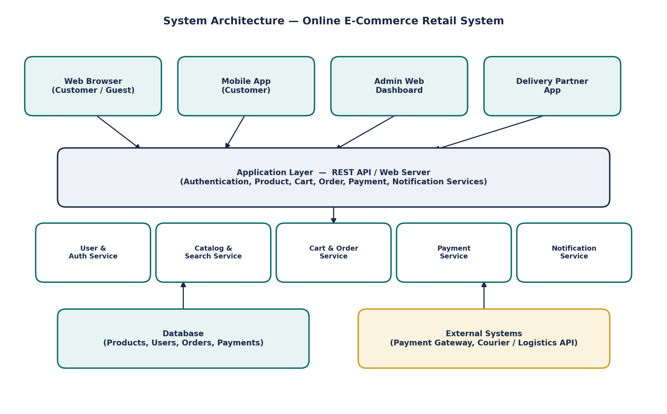
Figure 2: High-Level System Architecture — Online E-Commerce Retail System

8.1 Key System Features Summary
Feature | Description
Product Search & Discovery | Keyword search, category filters, and personalised recommendations
Shopping Cart | Persistent, real-time cart with quantity and price updates
Secure Checkout | Multi-step checkout with address selection and coupon application
Multi-Mode Payment | Card, UPI, net banking, and cash-on-delivery support via gateway integration
Order Tracking | Real-time order and delivery status visibility for customers
Admin Dashboard | Catalogue, inventory, order, and promotion management in one interface
Sales Reporting | Configurable sales, revenue, and inventory reports for decision-making
Ratings & Reviews | Verified-purchase product reviews to build customer trust

9. Assumptions and Constraints

9.1 Assumptions
- Customers have access to a stable internet connection and a modern web browser or smartphone.
- Third-party payment gateway and logistics providers offer reliable, documented APIs for integration.
- Product inventory data provided by the business/vendors is accurate at the time of listing.
- Users provide valid and truthful information during registration and checkout.
- The business will provide a valid payment gateway merchant account before go-live.

9.2 Constraints
Type | Constraint Description
Technical | The system must integrate with existing/selected third-party payment and logistics APIs, limiting flexibility to their supported features and rate limits.
Operational | Customer support and order fulfilment processes must align with the business's existing warehouse/delivery operations.
Economic | Development and infrastructure costs must remain within the allocated project/business budget, which may limit initial scalability provisioning.
Legal | The system must comply with applicable data protection regulations (e.g. IT Act, consumer protection rules) and PCI-DSS for payment data handling.
Time-related | The system must be delivered within the academic/project timeline, which constrains the scope of features implemented in the first release.

10. Requirement Validation — Completeness and Consistency

10.1 Stakeholder Requirement Coverage Check
Each identified stakeholder group's core needs have been cross-checked against the functional and non-functional requirements listed in Sections 3 and 4:
Stakeholder | Addressed By | Status
Customer | FR-01 to FR-15, FR-19, FR-27, FR-29 | Covered
Admin / Business Owner | FR-10, FR-22 to FR-26 | Covered
Delivery Partner | FR-28, FR-29 | Covered
Payment Gateway | FR-16, FR-17 | Covered
Security & Compliance Needs | NFR – Security, Reliability | Covered

10.2 Checks for Ambiguity, Redundancy, and Inconsistency
- Ambiguity: Requirement wording was reviewed to remove vague terms (e.g. 'fast' was replaced with measurable performance targets in NFR-Performance).
- Redundancy: Overlapping requirements between cart persistence (FR-12) and order creation (FR-11, FR-13) were reviewed and kept distinct to avoid duplication of logic.
- Inconsistency: Cross-checked that order status values referenced across FR-18, FR-19, FR-21, and the Order data entity remain consistent (Pending Payment, Confirmed, Shipped, Delivered, Cancelled).
- Missing Requirements: Initial review identified a gap in handling out-of-stock items during checkout; this has been addressed as an exception flow in UC-01.

10.3 Suggested Improvements
- Introduce a formal requirement traceability matrix (RTM) linking each FR/NFR to design components and test cases.
- Add explicit requirements for multi-language and multi-currency support if the business plans regional expansion.
- Define measurable acceptance criteria for each use case to support automated testing.
- Conduct periodic stakeholder review sessions to validate that evolving business needs remain reflected in the SRS.

11. Conclusion
This Software Requirement Specification document presents a comprehensive analysis of the Online E-Commerce Retail System scenario, covering the business context, stakeholders, functional and non-functional requirements, actor and use-case modelling, data and interface requirements, system architecture, and a validation of requirement completeness and consistency. The requirements captured in this document provide a solid foundation for the subsequent design and development phases of the Software Development Life Cycle (SDLC), ensuring that the delivered system aligns with both business objectives and customer expectations.

